

**FORT BEND EDUCATION FOUNDATION**

**AWARDS $15,107.66 TO**

Austin Parkway

Through the years, Austin Parkway has been awarded $167,854.39 in grants by the Fort Bend Education Foundation.

Established in 1992 to benefit students of Fort Bend ISD, this non-profit organization is governed by a volunteer board of directors that includes local business, industry, and community leaders. The Foundation provides funds to support innovative academic projects and staff development activities where traditional funding is not available. Some examples of the many grants funded to teachers include digital microscopes, math manipulatives, mobile science labs, big books, “History Alive” materials, and gardening systems. Since its inception, the Fort Bend Education Foundation has awarded nearly $35 million dollars in grants to Fort Bend ISD teachers and schools. Please consider supporting the Education Foundation by volunteering your time at any one of our fundraisers, adopting a new teacher, donating an auction item, or attending the annual gala in February.  **If you are looking for a great way to pay tribute to a teacher or loved one, consider making a donation to our Tribute Fund.**

More information about the Foundation can be found on the website, [www.fortbendisd.com/foundation](http://www.fortbendisd.com/foundation) or you may contact Brenna Cosby, Executive Director at 281-634-1113.



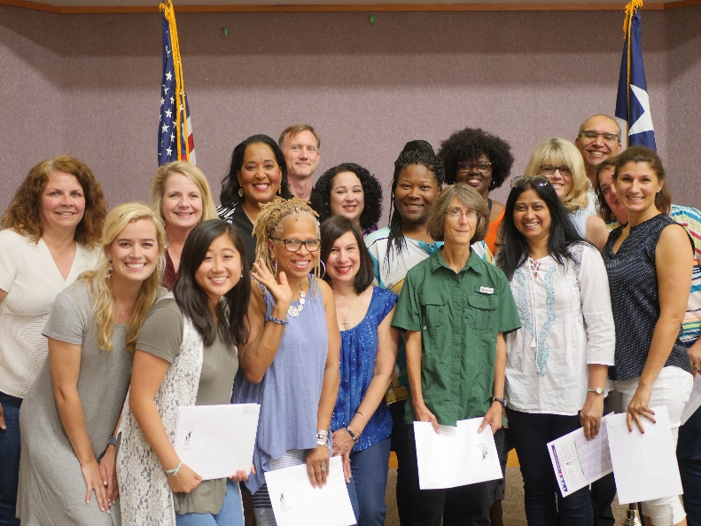

Pictured (l-r): First Row: Shannon Sinclair, Vivian Ngo-Anh, Renell Wilson-Scott, Tomalene Vaughn, Marla Berkowitz, Harshada Bawiskar, Debora Crowley, ; Second Row: Beth Snyder, Sue Sierra, Jimmy Guest, Stacey Johnson, Tanisha Joes, Salethia Morris, Angela Dratler, Amanda Griggs; Third Row: Dr. Charles Dupre, FBISD Superintendent